training 1 epoch...

68.83686518669128 seconds used......

1 training finished! average train loss: 0.7061629609929191

evaluating...

Confusion matrix, without normalization

[[ 0 24 21]

[ 0 135 51]

[ 0 21 333]]

Normalized confusion matrix

[[0. 0.53333333 0.46666667]

[0. 0.72580645 0.27419355]

[0. 0.05932203 0.94067797]]

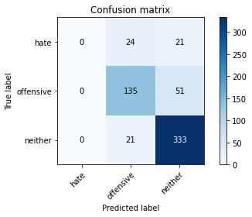

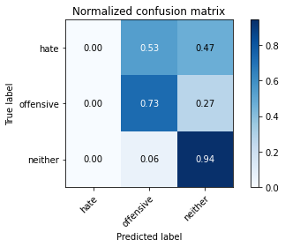

/usr/local/lib/python3.7/dist-packages/sklearn/metrics/_classification.py:1272: UndefinedMetricWarning: Precision and F-score are ill-defined and being set to 0.0 in labels with no predicted samples. Use `zero_division` parameter to control this behavior.

_warn_prf(average, modifier, msg_start, len(result))

precision recall f1-score support

hate 0.00 0.00 0.00 45

offensive 0.75 0.73 0.74 186

neither 0.82 0.94 0.88 354

accuracy 0.80 585

macro avg 0.52 0.56 0.54 585

weighted avg 0.74 0.80 0.77 585

average eval_loss: 0.5851251984635989, accuracy: 0.8

training 2 epoch...

72.6908495426178 seconds used......

2 training finished! average train loss: 0.4752186780047213

evaluating...

Confusion matrix, without normalization

[[ 20 10 15]

[ 9 134 43]

[ 8 25 321]]

Normalized confusion matrix

[[0.44444444 0.22222222 0.33333333]

[0.0483871 0.72043011 0.2311828 ]

[0.02259887 0.07062147 0.90677966]]

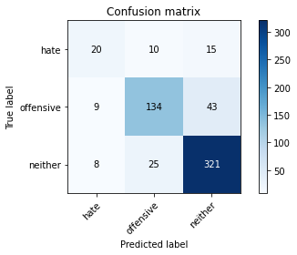

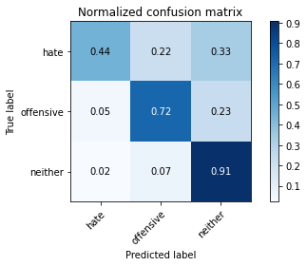

precision recall f1-score support

hate 0.54 0.44 0.49 45

offensive 0.79 0.72 0.75 186

neither 0.85 0.91 0.88 354

accuracy 0.81 585

macro avg 0.73 0.69 0.71 585

weighted avg 0.81 0.81 0.81 585

average eval_loss: 0.46977121432622276, accuracy: 0.811965811965812

training 3 epoch...

72.47432136535645 seconds used......

3 training finished! average train loss: 0.31276319831864446

evaluating...

Confusion matrix, without normalization

[[ 10 21 14]

[ 5 145 36]

[ 3 36 315]]

Normalized confusion matrix

[[0.22222222 0.46666667 0.31111111]

[0.02688172 0.77956989 0.19354839]

[0.00847458 0.10169492 0.88983051]]

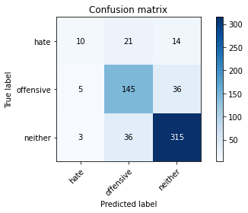

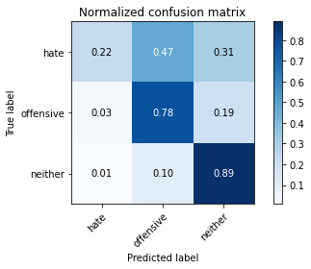

precision recall f1-score support

hate 0.56 0.22 0.32 45

offensive 0.72 0.78 0.75 186

neither 0.86 0.89 0.88 354

accuracy 0.80 585

macro avg 0.71 0.63 0.65 585

weighted avg 0.79 0.80 0.79 585

average eval_loss: 0.5289307311177254, accuracy: 0.8034188034188035

training 4 epoch...

72.1208381652832 seconds used......

4 training finished! average train loss: 0.1734459423022265

evaluating...

Confusion matrix, without normalization

[[ 15 18 12]

[ 7 136 43]

[ 14 20 320]]

Normalized confusion matrix

[[0.33333333 0.4 0.26666667]

[0.03763441 0.7311828 0.2311828 ]

[0.03954802 0.05649718 0.9039548 ]]

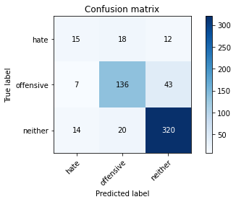

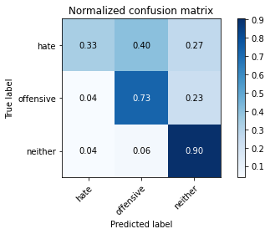

precision recall f1-score support

hate 0.42 0.33 0.37 45

offensive 0.78 0.73 0.76 186

neither 0.85 0.90 0.88 354

accuracy 0.81 585

macro avg 0.68 0.66 0.67 585

weighted avg 0.80 0.81 0.80 585

average eval_loss: 0.6401645404597124, accuracy: 0.8051282051282052

training 5 epoch...

72.22607660293579 seconds used......

5 training finished! average train loss: 0.09954611499670447

evaluating...

Confusion matrix, without normalization

[[ 18 18 9]

[ 16 137 33]

[ 14 46 294]]

Normalized confusion matrix

[[0.4 0.4 0.2 ]

[0.08602151 0.73655914 0.17741935]

[0.03954802 0.1299435 0.83050847]]

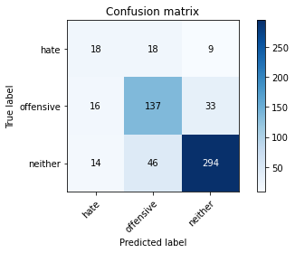

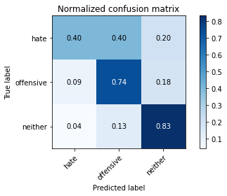

precision recall f1-score support

hate 0.38 0.40 0.39 45

offensive 0.68 0.74 0.71 186

neither 0.88 0.83 0.85 354

accuracy 0.77 585

macro avg 0.64 0.66 0.65 585

weighted avg 0.78 0.77 0.77 585

average eval_loss: 0.7390341222286224, accuracy: 0.7675213675213676

model of 2 epoch

Confusion matrix, without normalization

[[ 22 13 16]

[ 13 113 43]

[ 7 23 335]]

Normalized confusion matrix

[[0.43137255 0.25490196 0.31372549]

[0.07692308 0.66863905 0.25443787]

[0.01917808 0.0630137 0.91780822]]

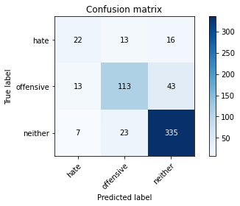

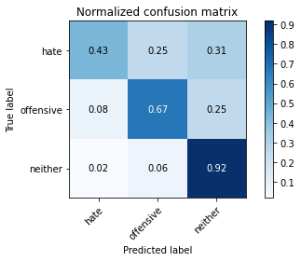

precision recall f1-score support

hate 0.52 0.43 0.47 51

offensive 0.76 0.67 0.71 169

neither 0.85 0.92 0.88 365

accuracy 0.80 585

macro avg 0.71 0.67 0.69 585

weighted avg 0.80 0.80 0.80 585

average eval_loss: 0.5137594302495321, accuracy: 0.8034188034188035

0.8034188034188035